**Running an NGINX Web Server in a Docker Container**

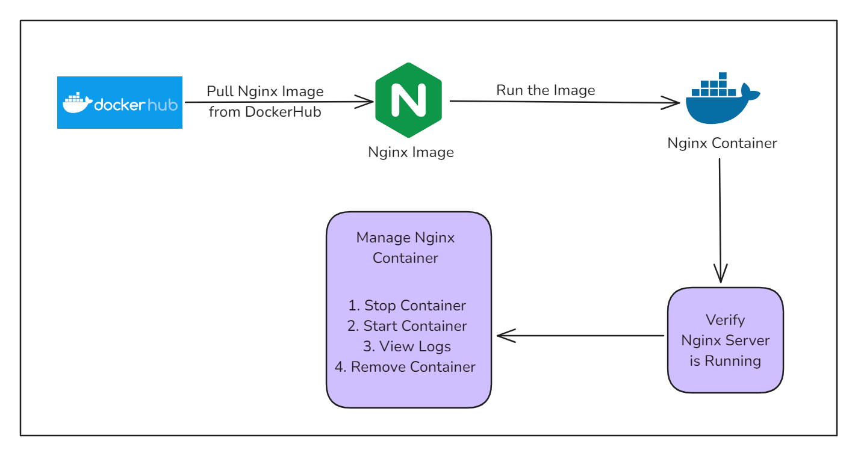This guide provides step-by-step instructions to set up and run an NGINX web server inside a Docker container. NGINX is a powerful web server and reverse proxy widely used for serving static content, load balancing, and more. Docker is a platform that allows you to easily create, deploy, and run applications in containers.

In this guide, we will demonstrate how to set up and run an NGINX web server inside a Docker container. By following these steps, you will learn how to pull the NGINX Docker image, configure a simple HTML file to be served by NGINX, and run the web server inside a container. Additionally, we will cover managing the NGINX container, including starting, stopping, viewing logs, and removing the container. This setup allows for a flexible and efficient way to deploy a web server using Docker’s containerization capabilities

**Prerequisites:**

Docker Installed: Ensure that Docker is installed and running on your system.

Basic Command Line Knowledge: Familiarity with the terminal or command prompt.

**Steps to Run NGINX in a Docker Container**

**1. Pull the NGINX Docker Image**

First, pull the NGINX image from Docker Hub by running:

docker pull nginx

This command downloads the latest NGINX image from the official Docker repository.

**2. Create a Directory for NGINX Content**

Create a directory on your system to hold the NGINX configuration files and web content:

mkdir -p ~/nginx/html

**3. Create a Simple HTML File**

Create a simple HTML file to be served by the NGINX web server:

echo '<h1>Hello, Docker!</h1>' > ~/nginx/html/index.html

**4. Run the NGINX Container**

Run the NGINX container, mapping the local directory to the container’s web root:

docker run --name my-nginx -v ~/nginx/html:/usr/share/nginx/html:ro -p 8080:80 -d nginx

**Explanation of the command options:**

* --name my-nginx: Names the container **my-nginx**.
* -v ~/nginx/html:/usr/share/nginx/html:ro: Maps the local ~/nginx/html directory to the container's /usr/share/nginx/html directory in read-only mode.
* -p 8080:80: Maps port 8080 on the host to port 80 in the container.
* -d nginx: Runs the NGINX container in detached mode.

**5. Verify the NGINX Server**

To verify the container is running:

docker ps

This command lists all running containers. You should see **my-nginx** listed.

To verify that the NGINX server is serving your content, use:

curl <http://localhost:8080>

You should see the following output:

<h1>Hello, Docker!</h1>

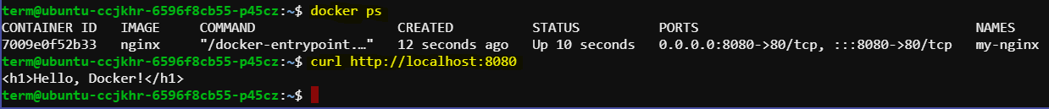

**Managing the NGINX Container**

**Stopping the Container**

**To stop the running NGINX container:**

docker stop my-nginx

**Starting the Container**

To start the stopped container:

docker start my-nginx

**Viewing Container Logs**

To view the logs of the NGINX container:

docker logs my-nginx

**Removing the Container**

To remove the NGINX container, first ensure it is stopped:

docker stop my-nginx

**Then remove the container:**

docker rm my-nginx

**Conclusion**

By following this guide, you have successfully set up and run an NGINX web server inside a Docker container. You have learned how to pull the NGINX image, configure a simple web page, and run the server in a containerized environment. Furthermore, you have been introduced to managing the container, including starting, stopping, and removing it. This streamlined approach simplifies web server deployment and management, providing a powerful way to handle web applications with ease and scalability